# Workshop: Augmented Reality with OpenCV and VTK

**Aim**: to give an overview of some of the techniques involved such as:

* Demo of a laparoscopic liver surgery system
* Understanding coordinate systems
* Camera calibration
* Merging video + models
* Discuss some visualisation aspects
* Build a complete system!
  + Webcam = video
  + Tracker = ArUco augmented reality tags
  + Phantom = Prostate/pelvis phantom

This knowledge should enable the student to assemble a basic AR system.

## 1. Demo of Laparoscopic Liver Surgery System:

1. Go to Level 2, Hampstead Road. See Matt Clarkson.
2. Aim is to display CT models on top of live laparoscopic video
3. Talk – overview of system components
   1. Optical Tracker
   2. Endoscopic stack
   3. NVidia SDI input
4. Perform “manual” registration using NiftySLS Liver Surgery plugin
5. Perform “ICP” registration using NiftySLS Liver Surgery plugin

(all steps will probably require live demo/assistance from Matt Clarkson).

1. Discuss Coordinate Systems – Compare “Laparoscopic System” with “Home Made” System (see Task 2)

**For Laparoscopic System**:

1. Laparoscope is tracked (T1)
2. Laparoscope has a camera, the intrinsic parameters (zoom, focus, centre of projection) are calibrated, and normally assumed to be fixed. However, it still has a position relative to the tracking balls on the Laparoscope. This relative transformation is called Hand-Eye (from robotic literature), here marked as T2.
3. When a surface is captured, we transform coordinates into “Tracker Space”, which is synonymous with “World Space”. To render things at the right position on screen, you simply need to mimic the transformations with your rendering system (VTK). In our case, the camera sits in “World Space”. So, once we register CT coordinates to “World Space”, here marked as T3, we can project the CT data, into the virtual camera, here marked as T4.
4. So, the basic rendering system is a case of geometry and setting up the rendering engine to mimic the correct geometry.

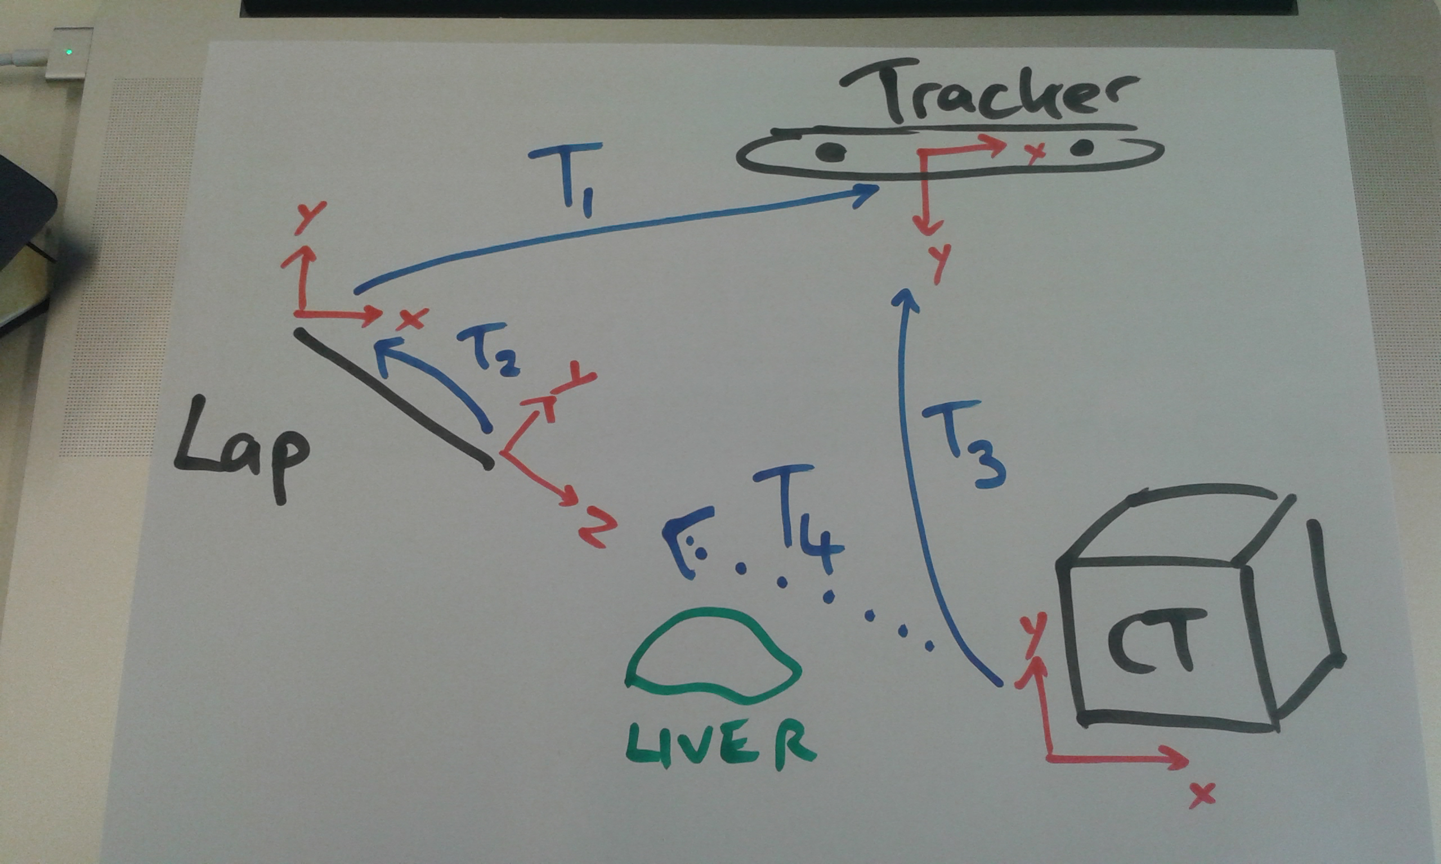

**Fig 1**: Laparoscopic coordinate systems.

**For “Homemade System”:**

1. We use a webcam. So, the camera intrinsic parameters are calibrated, exactly the same as the laparoscope.
2. We attach a reference board, with a set of ArUco markers. This defines the world coordinates. One corner is defined to be the origin etc. So, in the diagram below T5 is equivalent to T2 then T1.
3. So, if we register CT coordinates to the Reference, this is equivalent to registering the CT coordinates to the tracker in the example above. So, in both cases, these are labeled T3.
4. This registration is achieved by tracking a separate object (pointer), that can measure points relative to the Reference object? i.e. measures points in “World Space”.
5. So, this setup is slightly simpler than the laparoscope, but in principal, its enough to understand how such a system can be set up. Different systems might have slightly different arrangements of rigid body matrices, but the principal is the same.

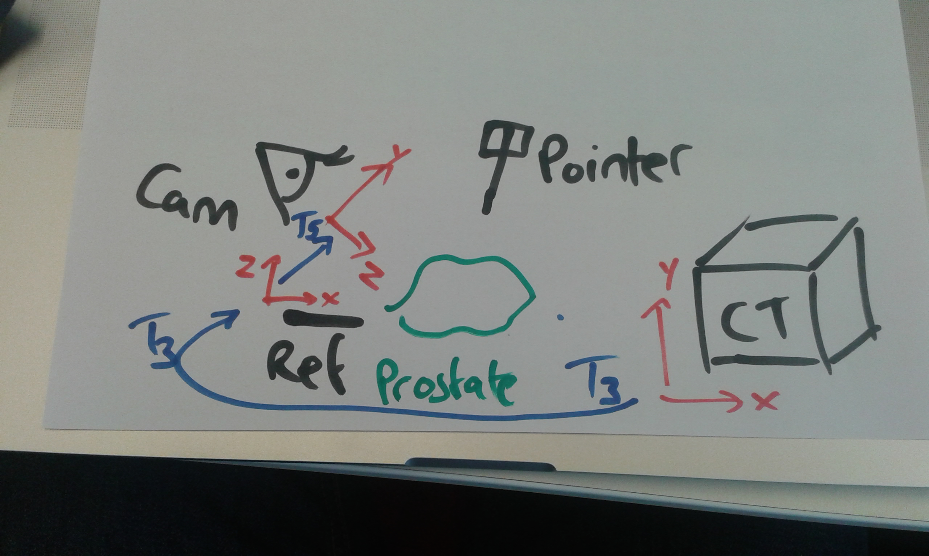

**Fig 2**: Phantom coordinate systems.

## 2. Build Your Own Image Guided Surgery System

(using common office components!)

1. Obtain a suitable test phantom, in this case a prostate phantom.

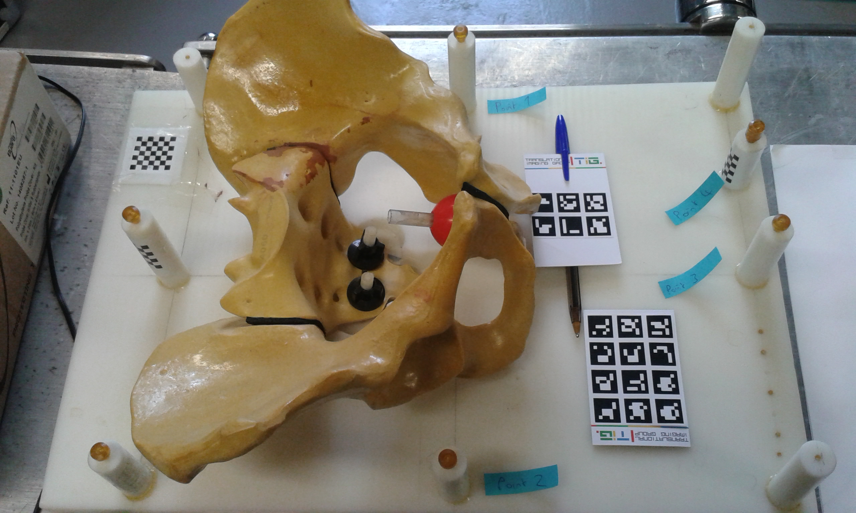

**Fig 3**. A prostate phantom, for which we have a CT scan, a reference marker, and a pointer.

2. Select a USB camera. There are 2 spare in Level 2 lab, Hampstead Road.

3. Calibrate USB camera.

(a) Take 5-20 pictures of chessboard using

bardGrabber -d <output_dir>

hitting the ‘d’ key to dump a video image to the output folder.

(b) Run the following, to get intrinsic parameters and distortion parameters

niftkCameraCalibration --help

niftkCameraCalibration --left <input_dir> --output <output_dir>

(filling in appropriate parameters)

Or use Matlab Calibration Toolbox.

(c) Repeat calibration twice – which parameters vary the most?

(d) What makes for good calibration images? If the console messages report that some images failed to be detected correctly, re-run the above with --writeImages

4. Attach reference object (3 x 4 barcode pattern) to the phantom. This defines the “world” coordinate system.

5. Run the following, and check that the USB camera can track the reference marker

bard -w ~/build/BARD/Data/ref.txt -i ~/build/BARD/Data/intrinsics.txt -x 1280 -y 720

where the –w option specifies a list of 3D coordinates and point IDs for each tag. The 2D/3D registration algorithm uses OpenCV cv::solvePnP algorithm to match 3D points to 2D points through a pinhole camera model.

6. In order to display CT data on-top of video, we need to register CT coordinates to “world” coordinates.

7. Open pelvis.vtk and pelvis.nii in NiftyView. Identify the fiducials, and note their 3D position in CT coordinates. See file ~/build/BARD/Data/CT.txt

8. Do pivot calibration of a pointer. Using the second (2 x 3 barcode pattern) to a pointer, e.g. pen. Run:

bard -w ~/build/BARD/Data/ref.txt -i ~/build/BARD/Data/intrinsics.txt -x 1280 -y 720 -p ~/build/BARD/Data/pointer.txt -r -d ~/BARD

This will dump tracking matrices for the pointer into the folder ~/BARD. Put all tracking matrices into 1 file.

bardPivotCalibration --help

bardPivotCalibration --matrixDirectory ~/BARD

or

bin/bardPivotCalibration -i trackingMatrices.txt -o pivot.txt

which will calculate a matrix, whose translational component is the offset of the pointer tip from the origin of the pointer model.

This will probably fail!!! Why?

9. Then, edit the pointer.txt file to contain the calibrated pointer position for point ID 9999. The format is

pointId x0 y0 z0 x1 y1 z1 x2 y2 z2 x3 y3 z3 x4 y4 z4

where point zero is the centre of the tag, followed by the 4 corners. Here we are using a dummy tag ID (9999) to represent the tip, so the centre and corners can all be the same point.

If the pivot calibration failed, simply work out the tip position by measuring it. The origin is the centre of the pattern, and the x and y axes are aligned with the tags.

10. For each point you want to measure, you should clear down (delete) the contents of ~/BARD (or write the data to a new folder). For each point run:

bard -w ~/build/BARD/Data/ref.txt -i ~/build/BARD/Data/intrinsics.txt -x 1280 -y 720 -p ~/build/BARD/Data/pointer.txt -t -d ~/BARD

(which if you compare with step 8, you are recording the tip position instead of the matrix).

Control-C to kill the program each time, and the last generated file will contain the location of the pointer tip. So, you can measure the position in world coordinates of the prostate phantom fiducials.

11. Create a plain text-file containing the coordinates of the prostate phantom fiducials. The file BARD/Data/CT.txt has 4 markers. These markers have been labeled on the phantom. You must measure the points using the tracked pointer, in the same order. You should end up with a file, of the same format as CT.txt, containing the corresponding world coordinates.

12. Compute the registration of CT points in CT.txt to your world points. E.g.

bardProcrustes -f world.txt -m moving.txt -o register.txt

13. Finally, we should be able to render the prostate CT model, overlaid on the live video using the following:

bard -w ~/build/BARD/Data/ref.txt -i ~/build/BARD/Data/intrinsics.txt -x 1280 -y 720 –m pelvis.vtk –a registration.txt

As the reference board is attached to the phantom, you should be able to move the camera, and observe the prostate model, overlaid on the video from different angles, as long as the tracking markers are in view.

13. Step through the registration process another 2 times, to see how repeatable it is. What is the mean FRE from your 3 attempts?

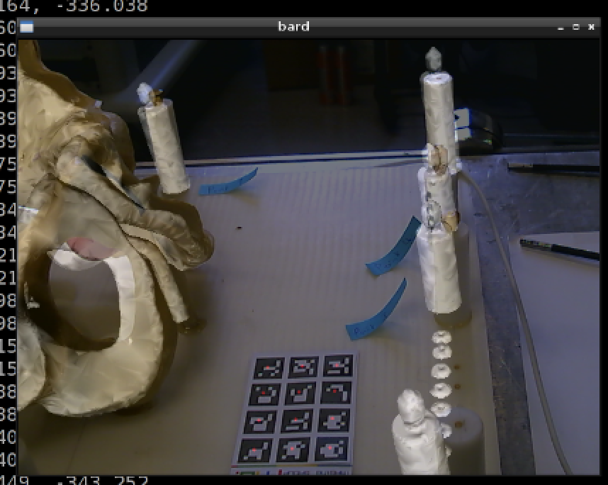

**Fig 4**: Screenshot after registration. FRE=12mm.

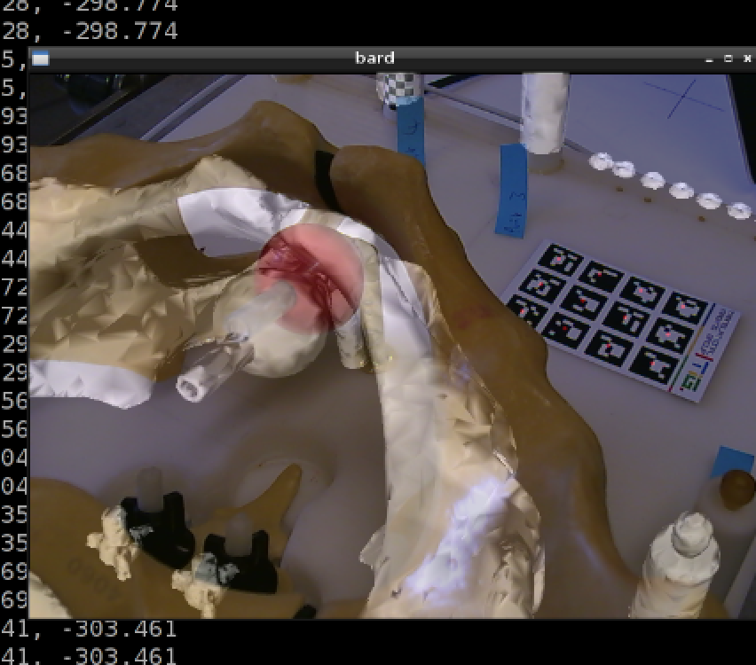

**Fig 5**: Screenshot after registration. FRE=12mm.

## 3. Ad-hoc Code Walkthrough

Matt can talk at length through the example code.

Basic Augmented Reality Demo (BARD)

Available: <https://github.com/MattClarkson/BARD>

with BSD license.

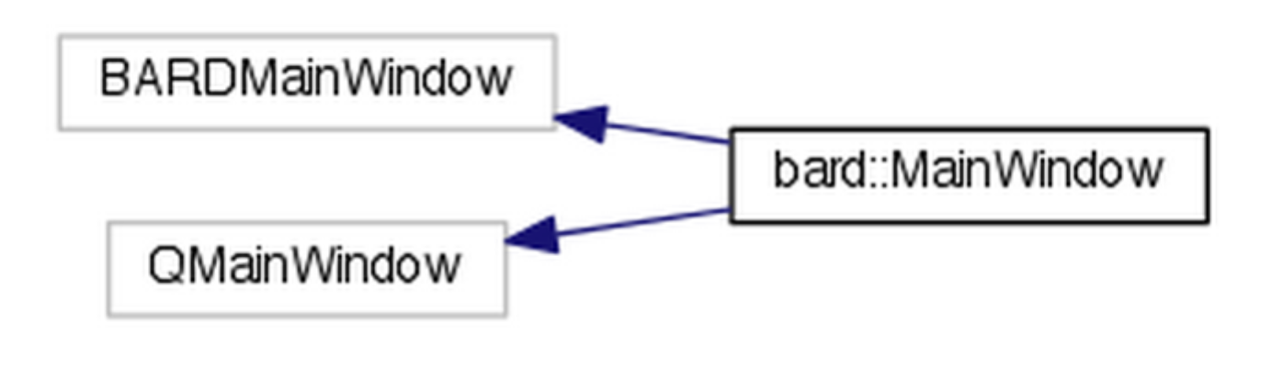

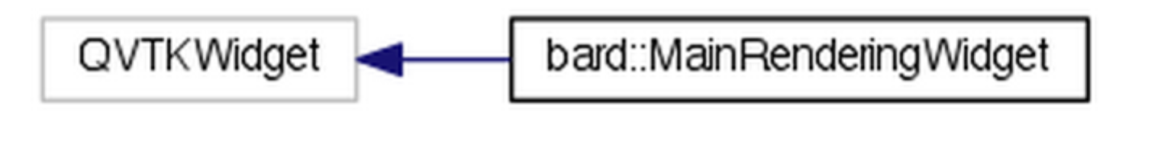 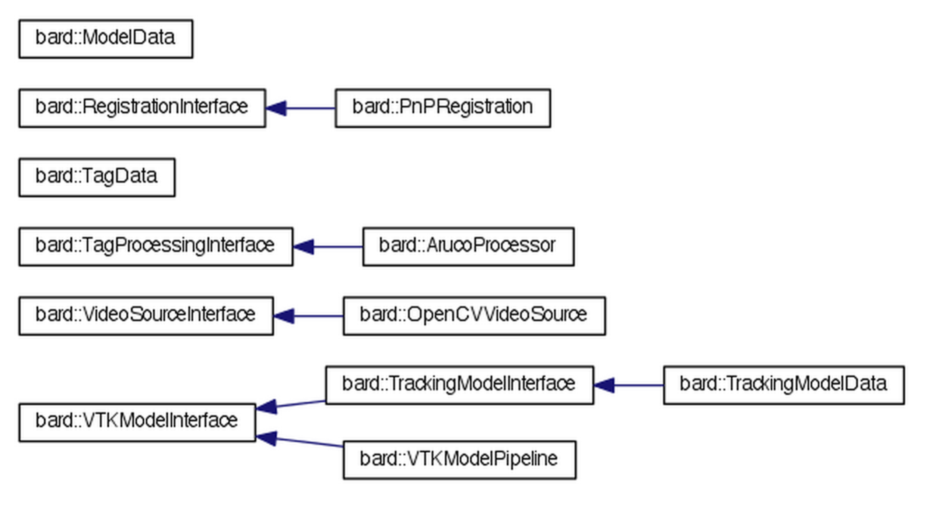

## 4. Coding Tasks

Relevant papers:

1. Camera calibration: [10.1109/34.888718](http://dx.doi.org/10.1109/34.888718)
2. Procrustes analysis (point based registration): [10.1109/TPAMI.1987.4767965](http://dx.doi.org/10.1109/TPAMI.1987.4767965)
3. Pivot/Pointer calibration: [10.1109/TMI.2007.907327](http://dx.doi.org/10.1109/TMI.2007.907327)

Coding tasks:

1. Camera calibration: Load a directory of images, and call cv::calibrateCamera.
2. Compare visualisation with VTK foreground, and background renderers. See function bard::MainRenderingWidget::UpdateLayers().
3. Add GUI components to move Liver model around w.r.t. World Coordinate system.
4. Unit tests.
5. Try different PnP algorithms.
6. Adapt to stereo to try and improve the pivot calibration.

Performance evaluation:

1. How might we cross validate the tracking accuracy of the pointer?
2. Measure the accuracy of translational measurement in X/Y plane, and in Z direction?
3. Use Polaris Spectra. Register CT to world (Polaris). We have CT to world (ArUco). Compute Spectra to ArUco coordinate system.
4. Measure tracking error at each of the 4 fiducials?